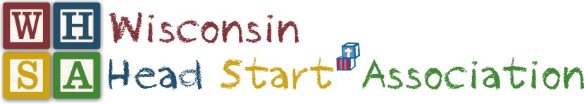
2019 SPRING QUARTERLY MEETING

April 1-3, 2019

The Concourse Hotel, Madison, WI

OVERVIEW AGENDA
Monday April 1, 2019
12:00-5:00 | Board of Directors Meeting  (University CD)  Lunch Provided
5:30-7:30 | Conference Steering Committee  (University CD)  Dinner Provided

Tuesday April 2, 2019

8:00-9:15 | PLWDG Committee 8:00-9:15  (Capitol Ballroom A)
9:30-11:30 | Opening General Session  (Capitol Ballroom B)  “Advocacy Keynote” - Dr. Tim Nolan
11:30-12:30 | Buffet Luncheon  (Capitol Ballroom B)
12:30-3:30 | Day at the Capitol – Meeting with Legislators
12:30-3:30  * See below | Capitol visits or Collaboration Conversation with Jennie Mauer 12:30-3:30  (Capitol Ballroom A) |  | Community of Practice: EHS  (Conference Room 1)  Facilitators: Lillian Mallinson & Linda Langosch | Community of Practice: Family Services  (Conference Room 2)  Facilitator: Donna Morris | Community of Practice: Home Visiting / Mental Health  (Conference Room 3)  Facilitators:  Bonnie Phernetton & Wendy Schwalbe
3:45-4:45 | Recap of Capitol Visits / Celebrating our Success 3:45-4:45  (Capitol Ballroom B)  Supported by the Parent Affiliate  Snacks Provided for All Quarterly Attendees
3:45-4:45 | Director Affiliate  Meeting  (Capitol Ballroom A) | Staff Affiliate  Meeting  (University Room CD)
Wednesday April 3, 2019
7:30-8:30 | Breakfast Buffet  7:30-8:30 am  (Capitol Ballroom B) |  |  | New Member Orientation  7:30 – 8:30 am  (University Room CD) |  | Advocacy Work Group Meeting  7:30 – 8:30am  (Capitol Ballroom A)
8:30 -11:30 | Director Affiliate  Meeting  (Capitol Ballroom A) | Parent Affiliate  Meeting  (University Room AB) | Staff Affiliate  Meeting  (University Room CD) |  | Community of Practice: EHS  (Conference Room 1)  Facilitator: Lillian Mallinson & Linda Langosch |  | Community of Practice: Family Services  (Conference Room 2)  Facilitator: Donna Morris
11:30 -12:00 | Closing General Session  (Capitol Ballroom B)
12:15 | Board of Directors Meeting (Capitol Ballroom A)  Lunch Provided
* 12:30-3:30 - Affiliate Members will participate in Capitol Visits or Collaboration Gathering with Jennie Mauer.

