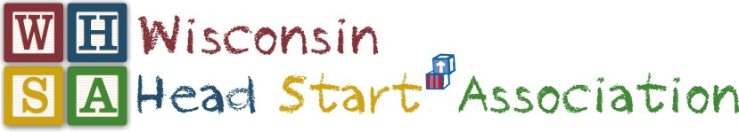
2019 WINTER QUARTERLY MEETING
January 8-10, 2019
The Osthoff Resort – Elkhart Lake, WI

COMMUNITIES OF PRACTICE AGENDA

Facilitators: Lillian Mallinson, Linda Langosch, Michelle Genthe, Joni Thoresen, LaNissa Trice, Angel Stoddard and Yolanda Winfrey

Wednesday, January 9th & Thursday, January 10th

EHS Community of Practice: facilitated by Lillian Mallinson and Linda Langosch

- Welcome/Introductions
- Relationship based competencies for home visitors and center-based staff
- Trauma informed work environments
- Addressing challenging behaviors utilizing Conscious Discipline and Pyramid Model
- EHS professional development and workforce

Health & Wellness Community of Practice: facilitated by Michelle Genthe, Joni Thoresen & LaNissa Trice

- Welcome/Introductions
- Overview of Health Managers Network/Purpose
- Updates from the National Center on Early Childhood Health and Wellness
- Obtaining Health Follow up
- Managing PIR Data
- Staff Turnover
- Staff Wellness
- Next Steps

Education Managers & Specialists Community of Practice: facilitated by Angel Stoddard

January 9 (1-4pm)
- Welcome/Introductions and Round-Table discussion on CoP
- Facilitated Discussion: All Things Curriculum
- …with fidelity (What? and How?)
- …through professional development (data-driven)
January 10 (8:30-11:30am)
- Reflective Practice Activity
- Facilitated Discussion: Well-being of children, families, and staff
- Show and Share: Initiatives with Resources
- Nature-based
- Farm-to-Table
- Wonders of Learning
- Others?

Leadership Community of Practice: facilitated by Yolanda Winfrey

- Welcome/Introductions
- Leadership, Elections and the WHSA By-Laws

