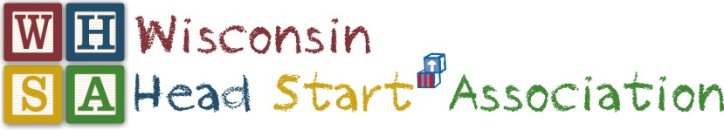
2019 WINTER QUARTERLY MEETING

January 8-10, 2019

The Osthoff Resort – Elkhart Lake, WI

OVERVIEW AGENDA
Tuesday: January 8, 2019
Board of Director’s Meeting (Elkhart Lake Ballroom)
12:00-5:00
Lunch in Room
Conference Steering Committee (Elkhart Lake Ballroom)
5:30-7:30
Dinner in Room

Wednesday: January 9, 2019
PLDWG (Villa Gottfried A)
8:00 – 9:15 am
Facilitator: TBD
General Assembly (Palm Garden A-B)
9:30 - 11:30 am
Welcome: Dr. Tim Nolan
Keynote Speakers: Linda Langosch and LaNissa Trice – Office of Head Start TTA
Topic: “Staff Wellness through Mindfulness”
WHSA Luncheon (Palm Garden A-B)
11:45 - 12:45 pm
Event Highlights: Parent Affiliate “POP” Scholarship Raffle
Community of Practice:  EHS  (Palm Garden D)  1:00 – 4:00 pm  Facilitator: Lillian Mallinson & Linda Langosh | Community of Practice:  Health & Wellness  (Palm Garden E)  1:00 – 4:00 pm  Facilitator: Michelle Genthe, Joni Thoresen & LaNissa Trice | Community of Practice: Education Managers & Specialists  (Palm Garden F)  1:00 – 4:00 pm  Facilitator: Angel Stoddard | Community of Practice: Leadership  (Villa Gottfried B)  1:00 – 4:00 pm  Facilitator: Yolanda Winfrey | Parent Affiliate Special Session:  “Beginning a Fatherhood Initiative”  (Villa Gottfried Parlor)  1:00 – 4:00 pm  Presenter: Erick Williams | Director Affiliate & Head Start State Collaboration Meeting  (Villa Gottfried A)  1:00 – 4:00 pm  Facilitator: Hillary Gunther & Jennie Mauer  (Call-in equipped)
Strategic Work, Committees, Taskforce & Tapas (Palm Garden A-B)
By-Laws, Parent Voices, Workforce, Professional Development, etc.
4:00 – 5:00 pm
Light appetizers included. Everyone Welcome!
New Member Orientation (Villa Gottfried A)
5:00 – 6:00 pm
Facilitator: Jen Bailey & Dr. Tim Nolan

Thursday, January 10, 2019
Hot Breakfast Buffet Palm Garden A-B)  7:30 – 8:30 am |  |  |  | Community Relations/Advocacy (Villa Gottfried B)  7:30 – 8:30 am  Facilitators: Dr. Tim Nolan & Carol Jackomino
Director Affiliate  (Villa Gottfried B)  8:30-11:30 am  Affiliate President: Hillary Gunther  (Call-in equipped) | Staff Affiliate  (Villa Gottfried A)  8:30-11:30 am  Affiliate President: Jessica Nemecek | Parent Affiliate  (Palm Garden F)  8:30-11:30 am  Affiliate President: Falcen Whitston | Community of Practice: EHS  (Palm Garden D)  8:30-11:30 am  Facilitator: Lillian Mallinson & Linda Langosh |  | Community of Practice: Health & Wellness  (Palm Garden E)  8:30-11:30 am  Facilitator: Michelle Genthe, Joni Thoresen & LaNissa Trice | Community of Practice: Education Managers & Specialists  (Grand Libelle F)  8:30-11:30 am  Facilitator: Angel Stoddard
General Assembly - Committee Report Out Session (Palm Garden A-B)
11:35 – Noon
Facilitator: Dr. Tim Nolan
Board of Directors (Villa Gottfried B)
12:15 - 1:30 pm
Board President: Dr. Tim Nolan
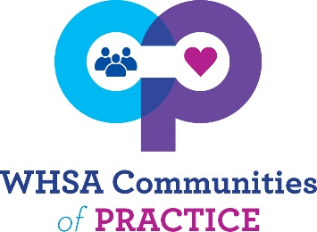
2019
Professional Development and networking that offers a richer experience of camaraderie with coworkers. Participants will examine multiple perspectives on ideas and practices, engage in deeper peer learning and shared enjoyment of work over time with trained facilitators leading workshops & discussions.
Question: What if I cannot attend the first COP meeting, can I still participate?
Yes! We understand new people are hired and life happens. We encourage you to attend any and all you believe will support your professional growth as a Head Start staff member. Participate in all that stir your interest.

Facilitators are committed to leading each group for a year.
Community of Practice | Facilitator | Meeting Dates
- Health & Wellness | Michelle Genthe  (Rock-Walworth)  Joni Thoresen (sheyboygan)  LaNissa Trice -supported | Fall Regional Conference, Fall Call (11/13/18 from 12-1pm), Winter Quarterly
- Early Head Start | Lillian Mallinson (STG)  Linda Langosh –supported | Winter & Spring Quarterly, Fall Call
- ERSEA | Rachel Smola (Cap Services), Karen Zdroik(cap Services),  Joan Keeler-Pellman  (Family forum) | Fall Quarterly, Annual Pre-Conf,  Spring Call,
- Inclusion/Disabilities | Michelle Ogerek (CESA 1) | Annual Conf, Spring Quarterly, Fall call
- Leadership Development | Yolanda Winfrey (National Centers for Learning Excellence) | Fall & Winter Quarterlies- Parents, staff and WHSA Board
- Family Services | Donna Morris | Fall Quarterly, Spring Quarterly,  Winter call
- Education managers & specialists | Angel Stoddard | Winter Quarterly, Annual Pre-conf  Spring Call
- Coaches | Ann Steffen (STG) | Fall Quarterly, Annual Pre-conf,  Spring Call
- Home Visiting | Staci Sontoski &  Bonnie Phernetton (UWM) | Spring Quarterly, Winter Call
- Compliance | Monica Brooks | Fall, annual conference, Spring call

- Education managers & specialists: Winter, pre-conference & Spring call
- Family Services: Fall, Spring & Winter call
- Health & Wellness: Winter & Fall Call
- Early Head Start: Winter, Spring, & Fall Call
- Coaches: Fall, pre-conference & Spring call
- ERSEA: Fall, pre-conference & spring call
- Inclusion & Disabilities: pre-conference, Spring, Fall call
- Leadership Development: Fall, Winter, & no calls
- Home Visiting/Mental Health- Spring, Winter call
- Compliance- Fall, Annual Conference, spring call

