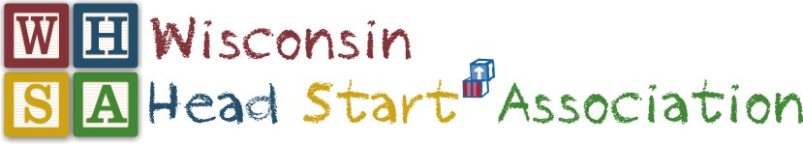
2018 FALL QUARTERLY MEETING

November 6-8, 2018

Chula Vista Resort, Wisconsin Dells

OVERVIEW AGENDA
Tuesday: November 6, 2018
Board of Director’s Meeting
12:30-5:00
Lunch included & Room
Conference Steering Committee
5:30-7:30
Dinner at 5:15 & Room
Wednesday: November 7, 2018
PLDWG
8:00 – 9:15 am
Facilitator: Yolanda Winfrey
General Assembly
9:30 - 11:30 am
Room:
Keynote Speaker: Maile Pa’alani, CPA and Senior Manager at WIPFLi
Topic: “Preparing for monitoring FA1 and FA2- it’s everyone’s business!”
Panel participants:

31th Annual Achieving Excellence Luncheon
Noon - 1:30 pm
Event Highlights: Awards Luncheon & Staff Raffle
Room:
Communities of  Practice 1  Compliance  1:45 – 4:45 pm  Facilitator: Maili Pa’lani  WIPFLi answers your questions! The process programs go through for successful program reviews,  Aligned Monitoring System 2.0 protocol.  Networking with other staff focused on program compliance for quality Head Start experiences | Communities of  Practice 2  ERSEA  1:45 – 4:45 pm  Facilitators:  Rachel Smola & Karen Zdroik (CAP Services), Joan Keeler-Pellman (Family Forum)  Topic: Starting off right… Attendance and Enrollment  Networking with other staff focused on ERSEA | Communities of  Practice 3  Coaches  1:45 – 4:45 pm  Facilitator: Ann Steffen (STGi)  Topic: Reflective practice and getting the outcomes you want.  Identifying future topics for COP and networking for staff in coaching and leadership roles | Communities of  Practice 4  Family Services  1:45 – 4:45 pm  Facilitator: To be Determined  Topic: Family goal setting- tracking outcomes and supporting families in the up’s and down’s of living their life.  Networking with other Family Service staff | Communities of  Practice 5  Leadership development  1:45 – 4:45 pm  Facilitator: Yolanda Winfrey (National Centers for Learning Excellence)  Topic: Following up the Leadership Training- Building trust within your affiliates, teams, committees. Best practices for decision making.  Parent & Staff Affiliate leaders | Director Affiliate & Head Start state collaboration meeting  1:45 – 4:45 pm  Topics:  State updates with Jennie Maunnamalai & Sherry Kimball from DPI  State Supplemental Grant funding  Q & A and networking  Advocacy and the election results on Head Start programs
Strategic Work, Committees, Taskforce & Tapas (light appetizers)
Personnel, By-Laws, Parent Voices, etc.

Community Relations/Advocacy
6:00 – 7:00 pm
Facilitator: Dr. Tim Nolan
Advocacy update and planning for Day at the Capitol in April

Thursday, November 8, 2018
Hot Breakfast Buffet  General Assembly Room: TBD  7:30 – 8:30 am |  |  | New Member Orientation  7:30 – 8:30 am  Facilitator: Dr. Barb Tengesdal
Director Affiliate  8:30-11:30 am  Affiliate President: Hillary Gunther | Staff Affiliate  8:30-11:30 am  Affiliate President: Jessica Nemecek | Parent Affiliate  8:30-11:30 am  Affiliate President: Falcen Whitston  Parent Voices Coordinator:  Rasami Moua |  | Communities of  Practice  Systems Integration- ERSEA, Family Services, Compliance  8:30 – 11:30 am  Facilitator: Yolanda Winfrey
General Assembly - Committee Report Out Session
11:35 – Noon
Facilitator: Dr. Barb Tengesdal
Board of Directors
12:15 - 1:30 pm
Board President: Dr. Tim Nolan
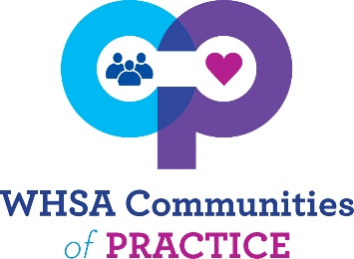
2018-2019
Professional Development and networking that offers a richer experience of camaraderie with coworkers. Participants will examine multiple perspectives on ideas and practices, engage in deeper peer learning and shared enjoyment of work over time with trained facilitators leading workshops & discussions.
Question: What if I cannot attend the first COP meeting, can I still participate?
Yes! We understand new people are hired and life happens. We encourage you to attend any and all you believe will support your professional growth as a Head Start staff member. Participate in all that stir your interest.

Facilitators are committed to leading each group for a year.
Community of Practice | Facilitator | Meeting Dates
- Health & Wellness | Michelle Genthe  (Rock-Walworth)  Joni Thoresen (sheyboygan)  LaNissa Trice -supported | Fall Regional Conference, Fall Call, Winter Quarterly
- Early Head Start | Lillian Mallinson (STG)  Linda Langosh –supported | Winter & Spring Quarterly, Fall Call
- ERSEA | Rachel Smola (Cap Services), Karen Zdroik(cap Services),  Joan Keeler-Pellman  (Family forum) | Fall Quarterly, Annual Pre-Conf,  Spring Call,
- Inclusion/Disabilities | Michelle Ogerek- CESA 1 | Annual Conf, Spring Quarterly, Fall call
- Leadership Development | Yolanda Winfrey - | Fall & Winter Quarterlies- Parents, staff and WHSA Board
- Family Services | Donna Morris ? | Fall Quarterly, Spring Quarterly,  Winter call
- Education managers & specialists | Angel Stoddard | Winter Quarterly, Annual Pre-conf  Spring Call
- Coaches | Ann Steffens (STG) | Fall Quarterly, Annual Pre-conf,  Spring Call
- Home Visiting | Staci Sontoski &  Bonnie Phernetton (UWM) | Spring Quarterly, Winter Call
- Compliance | Monica Brooks? | Fall, annual conference, Spring call

- Education managers & specialists: Winter, pre-conference & Spring call
- Family Services: Fall, Spring & Winter call
- Health & Wellness: Winter & Fall Call
- Early Head Start: Winter, Spring, & Fall Call
- Coaches: Fall, pre-conference & Spring call
- ERSEA: Fall, pre-conference & spring call
- Inclusion & Disabilities: pre-conference, Spring, Fall call
- Leadership Development: Fall, Winter, & no calls
- Home Visiting/Mental Health- Spring, Winter call
- Compliance- Fall, Annual Conference, spring call

