# Directions to Heidel House Resort 643 Illinois Avenue Green Lake, WI 54941

# 920- 294-3344 800- 444-2812

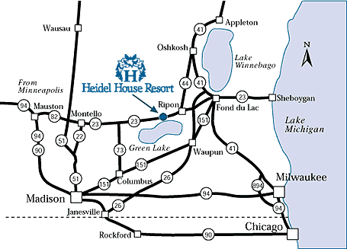

**From Madison**  
151 North to 73 North to 23 East to Green Lake. Turn right onto Business 23. Follow along the lake, into the city. At the stop sign, continue forward one block and turn right onto Lake Street. The road turns sharply to the left and becomes Illinois Avenue. On the right side, pass the Grey Rock Mansion entrance. Next right is Main Entrance. 643 Illinois Avenue.

**From Milwaukee**  
41 North to the Johnson Street/Highway 23 West exit in Fond du Lac. Turn left and follow Highway 23 West. Pass through Rosendale and Ripon. Continue on Highway 23 West to Green Lake. Turn left onto Business 23 into Green Lake, also known as Lawson Drive. Follow Business 23 to downtown Green Lake. Go left at the first stop sign, onto Mill Street (Business 23). Turn left at the next stop sign, onto South Street. Follow for one block, turning right onto Lake Street. The road turns sharply to the left and becomes Illinois Avenue. On the right side, pass the Grey Rock Mansion entrance. Next right is Main Entrance. 643 Illinois Avenue.

**From Chicago**  
I-94 North to Milwaukee. On the South side of Milwaukee, take the 894 bypass around Milwaukee to Highway 45 North, which turns into Highway 41. Take the Johnson Street/Highway 23 West exit in Fond du Lac. Turn left and follow Highway 23 West. Pass through Rosendale and Ripon. Continue on Highway 23 West to Green Lake. Turn left onto Business 23 into Green Lake, also known as Lawson Drive. Follow Business 23 to downtown Green Lake. At the first stop sign, turn left onto Mill Street (Business 23). Turn left at the next stop sign, onto South Street. Follow for one block, turning right onto Lake Street. The road turns sharply to the left and becomes Illinois Avenue. On the right side, pass the Grey Rock Mansion entrance. Next right is Main Entrance. 643 Illinois Avenue.

**From the Fox Valley**  
41 South to Highway 44 at Oshkosh. Follow Highway 44 West to Ripon, then Highway 23 West to Green Lake. Turn left onto Business 23 into Green Lake. Continue into downtown Green Lake. At the first stop sign, turn left onto Mill Street (Business 23). Turn left at the next stop sign, onto South Street. Continue forward one block, turning right onto Lake Street. The road turns sharply to the left and becomes Illinois Avenue. On the right side, pass the Grey Rock Mansion entrance. Next right is the Main Entrance. 643 Illinois Avenue.