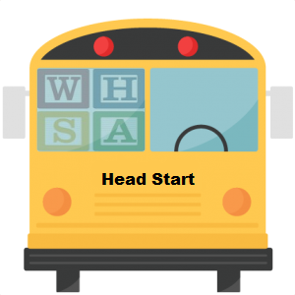 | WHSA 2018 Transportation Summit  Friday, September 28th, 2018  225 Osterman Dr.  Turtle Lake, WI

Join Wisconsin Head Start Association on September 28th for another excellent professional development and training event. The 2018 Transportation Summit will be held at CESA 11 in Turtle Lake, WI and will feature a variety of educated and knowledgeable presenters.

Agenda:
Registration Opens | 8:30 am
The Bus Driver Says: “I love you.” | 9:00 am – 11:00 am
Abbi Kruse, Executive Director at The Playing Field
This presentation will introduce the principles of Conscious Discipline and how classroom structures can be easily adapted for use on the bus.
The 3 P’s of Head Start Transportation | 11:00 am – 11:30 am
Beth Tilleson, Co-Director at CESA 11 Head Start & Early Head Start
Mona Karau, Transportation Manager at CESA 11 Head Start & Early Head Start
This section will touch on Head Start transportation focused performance standards, parent interaction, and the personal side of Head Start transportation.
Lunch | 11:30 am – 12:00 pm
Chicken kiev, cheesy potatoes, broccoli & raisin salad, tossed salad, and dinner roll.
Defensive Driving – The Skills that Set Us Apart in Child Education and Transportation | 12:00 pm – 4:00 pm
Charles Miller, Acting President of the Greater Milwaukee Safety Counsel
Participants will learn how to maintain control in an out-of-control traffic environment by anticipating scenarios and studying preventive and defensive actions in order to make Head Start transportation as safe has humanly possible.

